Do Now: Week of May 4 – May 8,2020 – Answer Sheet
Monday | Tuesday | Wednesday | Thursday | Friday
1)A toy box has a volume of 60 cubic feet. The box is 5 feet long and 4 feet wide. What is the height of the to box.  A. 20 feet  B. 10 feet  C. 3 feet  D. 5 feet | 1) What is the volume of the figure below?  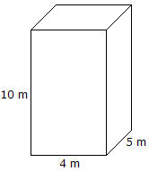  A. 20 cubic units  B. 19 cubic units  C. 45 cubic units  D. 200 cubic units | 1) What is the volume of the figure below?  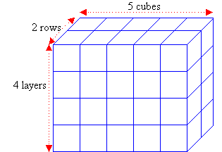  A. 11 cubic units  B. 40 cubic units  C. 20 cubic units  D. 25 cubic units | 1) Look at the box shown below.  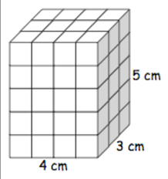  Which number sentence  correctly shows how to find the volume?  A. V= 5+3+4  B. V= 5 x 3 x 4  C. V= 4+4+4+3+5  D. V= 4 x 2 x 5 | 1) What is the volume of the figure below?  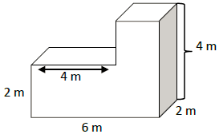  A. 5 cubic units  B. 12 cubic units  C. 18 cubic units  D. 32 cubic units
2) Which of the following most specifically describes a rhombus  A. a plane figure that is a polygon  B, A quadrilateral with 2 pairs of parallel lines.  C. a parallelogram with 4 equal sides.  4. a polygon with 4 sides. | 2) Manny has a piece of ribbon that is $\frac{1}{3}$ yard long. He cuts it into 2 equal lengths to make bookmarks. How long is each ribbon?  ^{A.} $\frac{2}{3}$ yard  ^{B.} $\frac{2}{6}$ yard  ^{C.} $\frac{1}{2}$ yard  ^{D.} $\frac{1}{6}$ yard | 2) Wen and five friends equally share $\frac{1}{3}$ of a pan of snack bars. Which expression shows how much of the pan each person gets.  - $\frac{1}{3}$ ÷ 6  - $\frac{1}{3}$ x 6  - $6$÷$\frac{1}{3}$  - $6 x \frac{1}{3}$ | 2) Rita is painting the walls in the playroom of the daycare center. She estimates that shew will need $\frac{1}{4}$ gallon of paint for each wall. How many walls can she paint with 5 gallons of paint.  _5_ ÷ __ $\frac{1}{4}$ __ = _20 | 2) Mrs. Wing is preparing to tape up posters made by her students on the wall. She cuts tape into $\frac{1}{4}$ foot pieces. How many $\frac{1}{4}$ foot pieces can she cut from 5 feet of tape.  A. 1$\frac{1}{4}$ foot pieces  B. 5 $\frac{1}{4}$ foot pieces  C. $\frac{5}{ 4 }$ foot pieces  D. 20 $\frac{1}{4}$ foot pieces
3) Elly babysits 3 hours a day for 4 days. On the fifth day, she babysits for 6 hours. Which expression represents hoe many hours Elly babysits altogether?  - 4 + 3+6  - 4 x (3 + 6)  - 3 x (4 + 6)  - 3 x 4 + 6 | 3) What is the value of the digit 5 when 2.5 is multiplied by 10²?  - 0.005  - 0.05  - 50  - 500 | 3) Find the difference.  7.6 – 2.567  5.033 | 3) How many times larger is the value of 5 in 540 than the value 5 in the number 5,400? | 3) Zoe is 16 years old. Her brother, Luke, is 3 more than half her age. Write a numerical expression for Luke’s age.  Possible answers  16 ÷ 2 +3 or (16 ÷ 2) +3 or $\frac{16}{2}$ + 3 or 16 x $\frac{1}{2}$ + 3 or $\frac{1}{2}$ x 16 + 3

